**AUTOMATED ATTENDENCE SYSTEM USING FACE RECOGNITION**

**ABSTRACT :-**

Marking up the Attendance physically is one of a major but important concern nowadays for the faculty members of any academic institution. There could be a indefinite human errors while performing this task. And to ensure the feasibility of the process of uploading all the attendance related data on the system is other concern. So to make the process smooth and effective we came up with an idea of Attendance using face recognition. In which a person would be marked as present using their facial features. The system would be using a camera to detect a face and then the recognition system would work to match the person’s face with the database. This system would be useful and effective for academic institutions and would be a great step towards digitalizing the process.

Keywords—Face Recognition; Face Detection; Haar-Cascade classifier; Local Binary Pattern Histogram; attendance system;

**PROPOSED SYSTEM :-**

All the students of the class must register themselves by entering the required details and then their images will be captured and stored in the dataset. During each session, faces will be detected from live streaming video of classroom. The faces detected will be compared with images present in the dataset. If match found, attendance will be marked for the respective student. At the end of each session, the final attendance will be uploaded on the excel sheet.

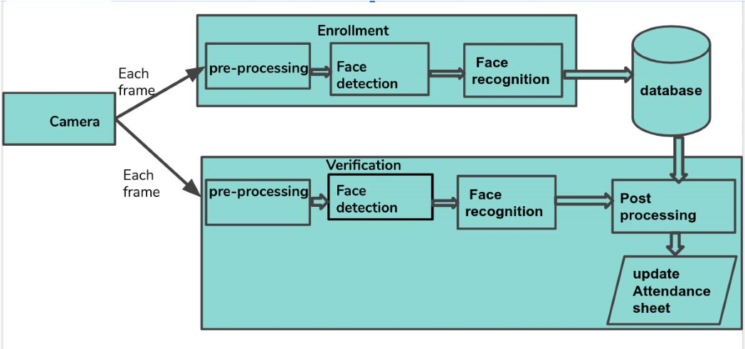

Typically this process can be divided into four stages,

1. **Dataset Creation :-**

Images of students are captured using a web cam. Multiple images of single student will be acquired with varied gestures and angles. These images undergo pre-processing. The images are cropped to obtain the Region of Interest (ROI) which will be further used in recognition process. Next step is to resize the cropped images to particular pixel position. Then these images will be converted from RGB to gray scale images. And then these images will be saved as the names of respective student in a folder.

1. **Face Detection** :-

Face detection here is performed using Haar-Cascade Classifier with OpenCV. Haar Cascade algorithm needs to be trained to detect human faces before it can be used for face detection. This is called feature extraction. The haar cascade training data used is an xml file haarcascade_frontalface_default. The haar features will be used for feature extraction. 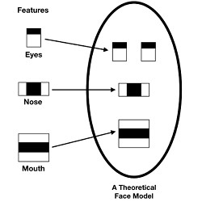

Here we are using detectMultiScale module from OpenCV. This is required to create a rectangle around the faces in an image. It has got three parameters to consider- scaleFactor, minNeighbors, minSize. scaleFactor is used to indicate how much an image must be reduced in each image scale. minNeighbors specifies how many neighbors each candidate rectangle must have. Higher values usually detects less faces but detects high quality in image. minSize specifies the minimum object size. By default it is (30,30) [8]. The parameters used in this system is scaleFactor and minNeighbors with the values 1.3 and 5 respectively.

# **3. Face Recognition :-**

Face recognition process can be divided into three steps- prepare training data, train face recognizer, prediction. Here training data will be the images present in the dataset. They will be assigned with a integer label of the student it belongs to. These images are then used for face recognition. Face recognizer used in this system is Local Binary Pattern Histogram. Initially, the list of local binary patterns (LBP) of entire face is obtained. These LBPs are converted into decimal number and then histograms of all those decimal values are made. At the end, one histogram will be formed for each images in the training data. Later, during recognition process histogram of the face to be recognized is calculated and then compared with the already computed histograms and returns the best matched label associated with the student.

# **4. Attendance Updation :-**

After face recognition process, the recognized faces will be marked as present in the excel sheet and the rest will be marked as absent. Faculties will be updated with monthly attendance sheet at the end of every month**CONCLUSION :-**

This system aims to build an effective class attendance system using face recognition techniques. The proposed system will be able to mark the attendance via face Id. It will detect faces via webcam and then recognize the faces. After recognition, it will mark the attendance of the recognized student and update the attendance record.